RBK EarlyBird Training Team  CHRIS CHONG  SENCO - Surbiton Children’s Centre Nursery  MARIE DOYLE  ASD Service Co-ordinator  ELEANOR HAINS  Family Care Worker  JANE HEWITT  Portage Worker  KAREN JERWOOD  Portage Worker  ANN MACPHERSON  Portage Co-ordinator  SHEILA TYLER  SEN Nursery Nurse - Surbiton Children’s Centre Nursery  MARGARET VYSE  Senior Educational Psychologist  COURSES WILL BE HELD AT  SURBITON CHILDREN’S CENTRE  ALPHA RD, SURBITON, KT5 8RS  Creche facilities are available |  | 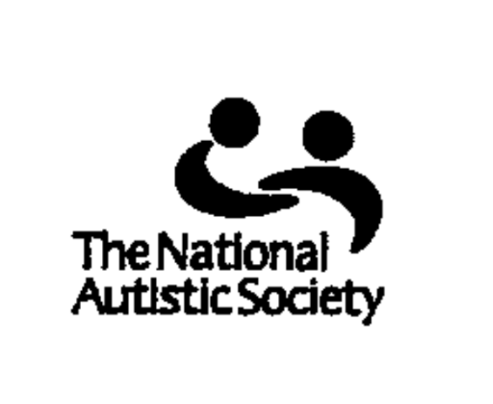  EarlyBird    EARLY INTERVENTION COURSE FOR PARENTS AND CARERS OF PRE-SCHOOL CHILDREN WITH AN AUTISM SPECTRUM DISORDER  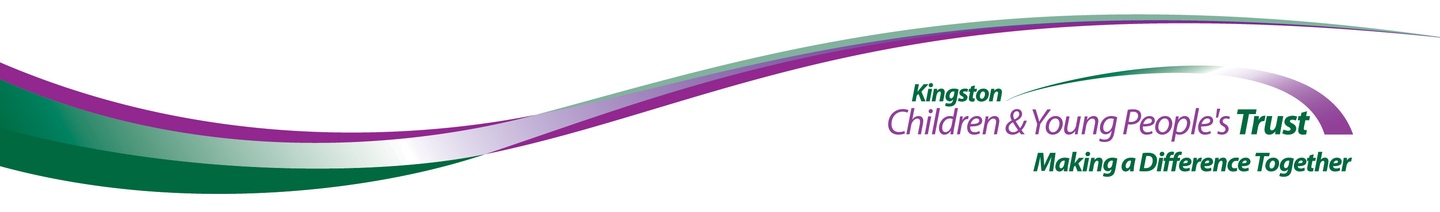
The NAS EarlyBird Programme* has been developed to support parents of pre-school children with a diagnosis of an autism spectrum disorder.  - It is a three month programme involving up to six families  - It brings parents together for daytime group training sessions once a week  - It involves families being visited during the programme in their own homes  *EarlyBird is a registered trademark of  The National Autistic Society |  | The NAS EarlyBird Programme works in partnership with parents to help them to:  - Understand their child’s autism spectrum disorder  - Develop their child’s communication skills  - Develop and apply practical strategies to manage their child’s behaviour  For details of the next information  meeting please contact:  Chris Chong on 020 8390 2555  (email: SHN@rbksch.org)

